**Documentation for Accommodation Office Support System**

This project aims to improve disability support services and streamline administrative processes at ESLSCA University.

It focuses on designing and implementing academic learning plans for students with disabilities, ensuring accessibility and equity in their educational experience.

**Intended Audience**

* **Students**: To submit disability-related forms and access personalized learning support plans.
* **Faculty**: To implement accommodations for students in their courses and exams.
* **Administrative Staff**: To review submissions, facilitate interviews, and manage the approval process for learning support plans.

**Challenges Addressed**

* Acceptance of which student in which school depending on the policy.
* Simplifying the submission and review process for disability evidence.
* Creating tailored academic learning plans to meet diverse disability requirements.
* Ensuring seamless communication and integration between stakeholders.

**Design and Features**

* The design shown in the pictures below is in the **development stage**.
* Features include:
  + A dashboard for managing forms, feedback, and calendars.
  + A system for submitting, reviewing, and approving learning support plans.
  + Integration with other university systems such as the self-service portal and the university website.

**Planned Features**

* Future integration with additional university systems.
* Notifications for users regarding the status of their submissions.
* Analytics for tracking and improving the support services.

**Workflow**

1. **Form Submission**: Students submit the Disability Evidence Form.
2. **Review**: Administrative staff review the submission.
3. **Interview**: Students are scheduled for an interview with the Accommodation Office.
4. **Plan Creation**: The Accommodation Office creates a tailored learning support plan based on the specific disability.
5. **Approval**: The plan is approved by the relevant department head (ie: BBA, BDT).
6. **Release**: The approved plan is shared with the student.

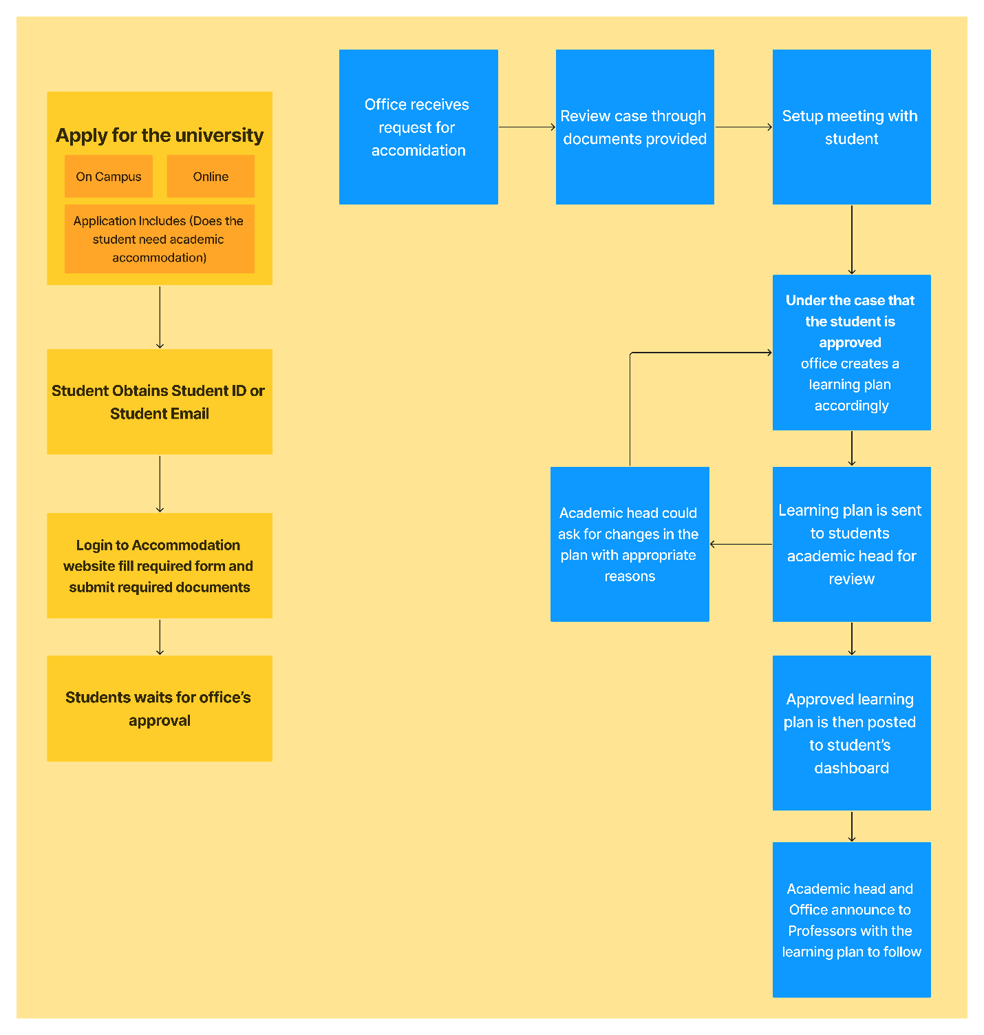

**Technology Stack (**MERN**)**

* **Frontend**: React.js
* **Backend**: Node.js with Express.js
* **Database**: MongoDB
* **API Integration**: Utilizes the University’s API for seamless data exchange.

**Accessibility**

* Currently, no specific accessibility standards (e.g., WCAG) are implemented.
* No direct support for assistive technologies, though future updates could address this.

**Maintenance and Future Expansion**

* **Current Maintenance**: The maintenance strategy is not defined yet.
* **Future Plans**:
  + Expanding the system to include other support services.
  + Developing a mobile application for improved accessibility and user experience.

**Summary**

This Disability Support System demonstrates ESLSCA University’s commitment to inclusivity and accessibility. By leveraging modern technologies and streamlining workflows, it ensures that students with disabilities receive the necessary accommodations to thrive academically.

**Pictures of the current development progress:**

**Home page**

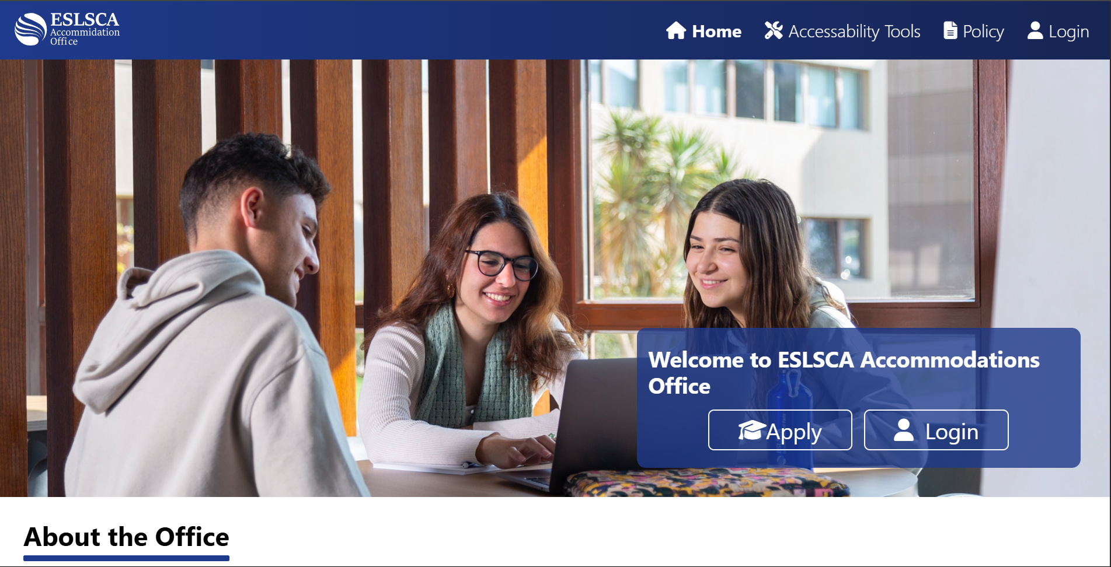

**About Section**

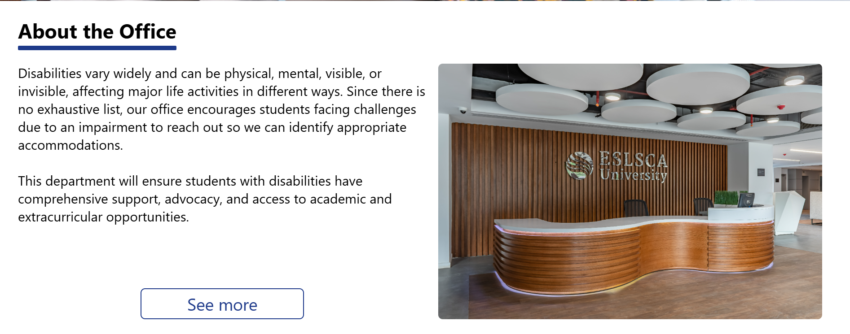

**Accommodations Provided Section**

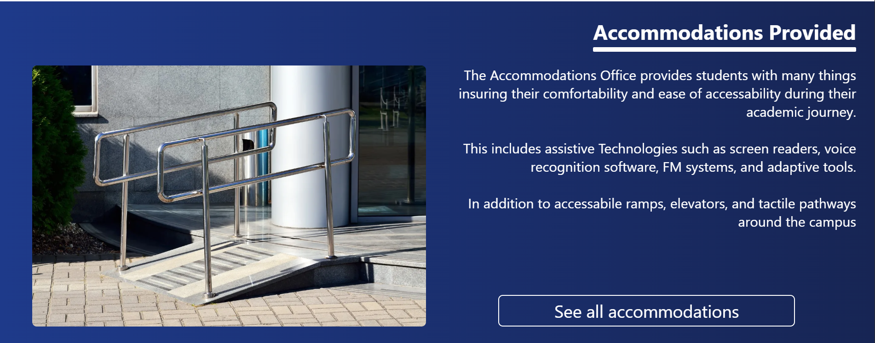

**Login Page**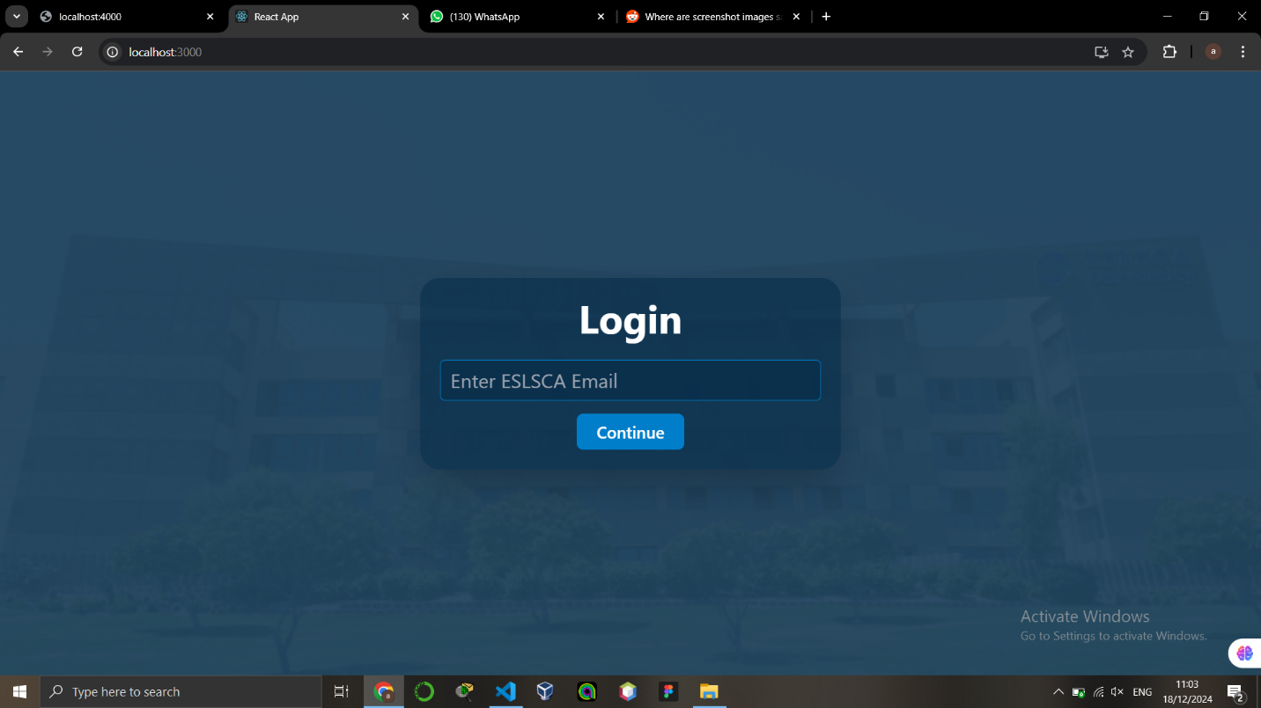

**Form Submission for Students**

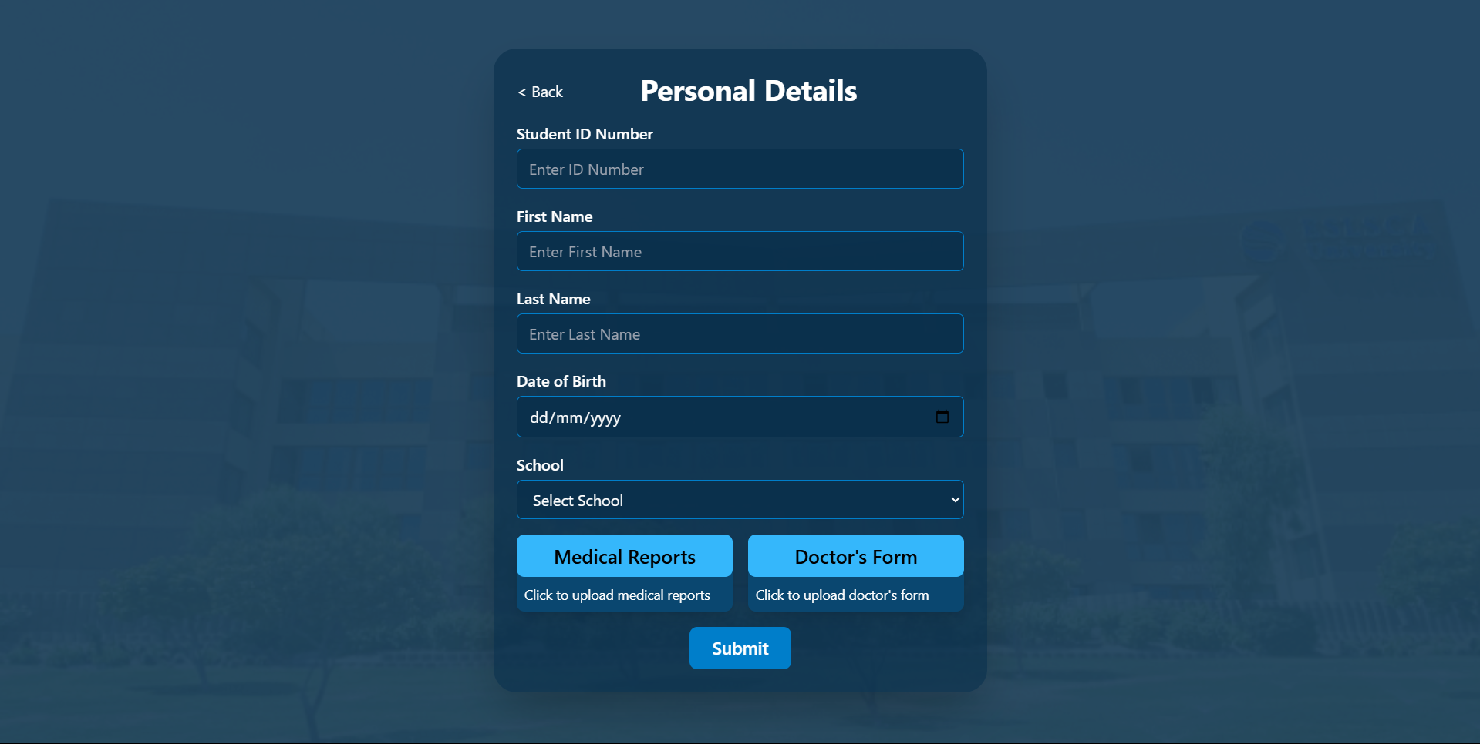

**Dashboard for Students**

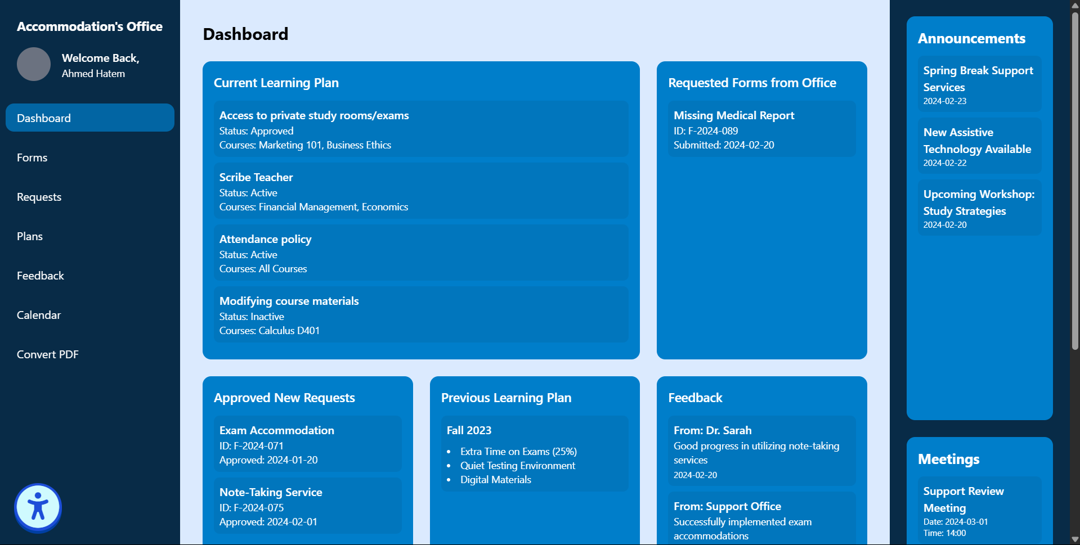

**Request Form Page for Students**

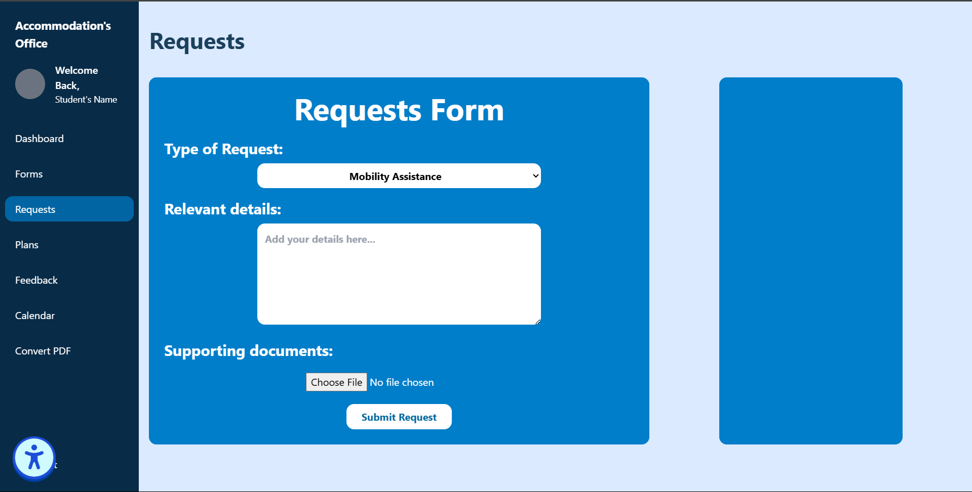

**PDF Converter for Students**

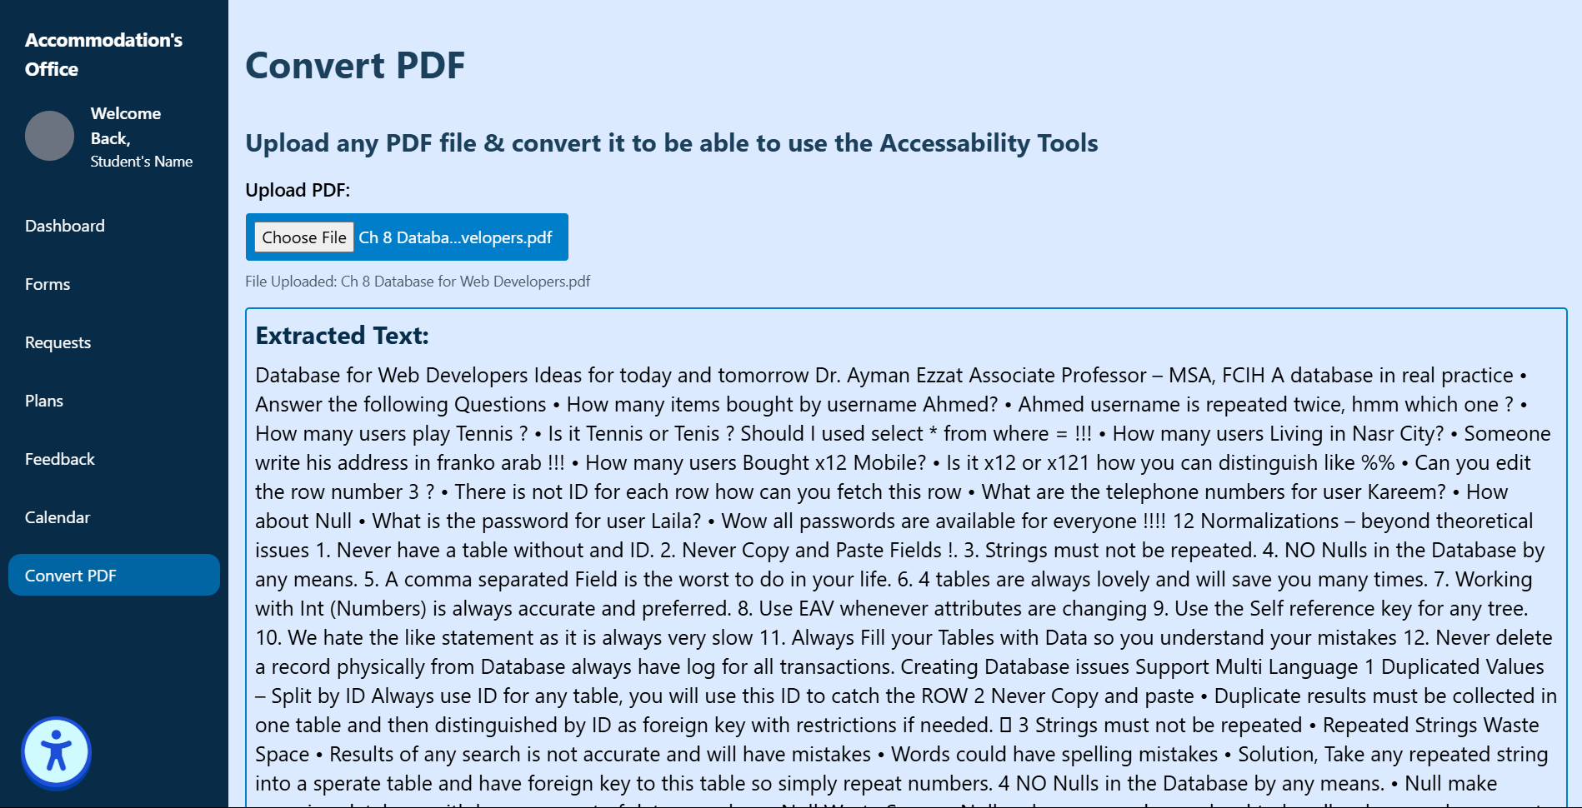

**Dyslexic font with screen indictator preview (help tools)**

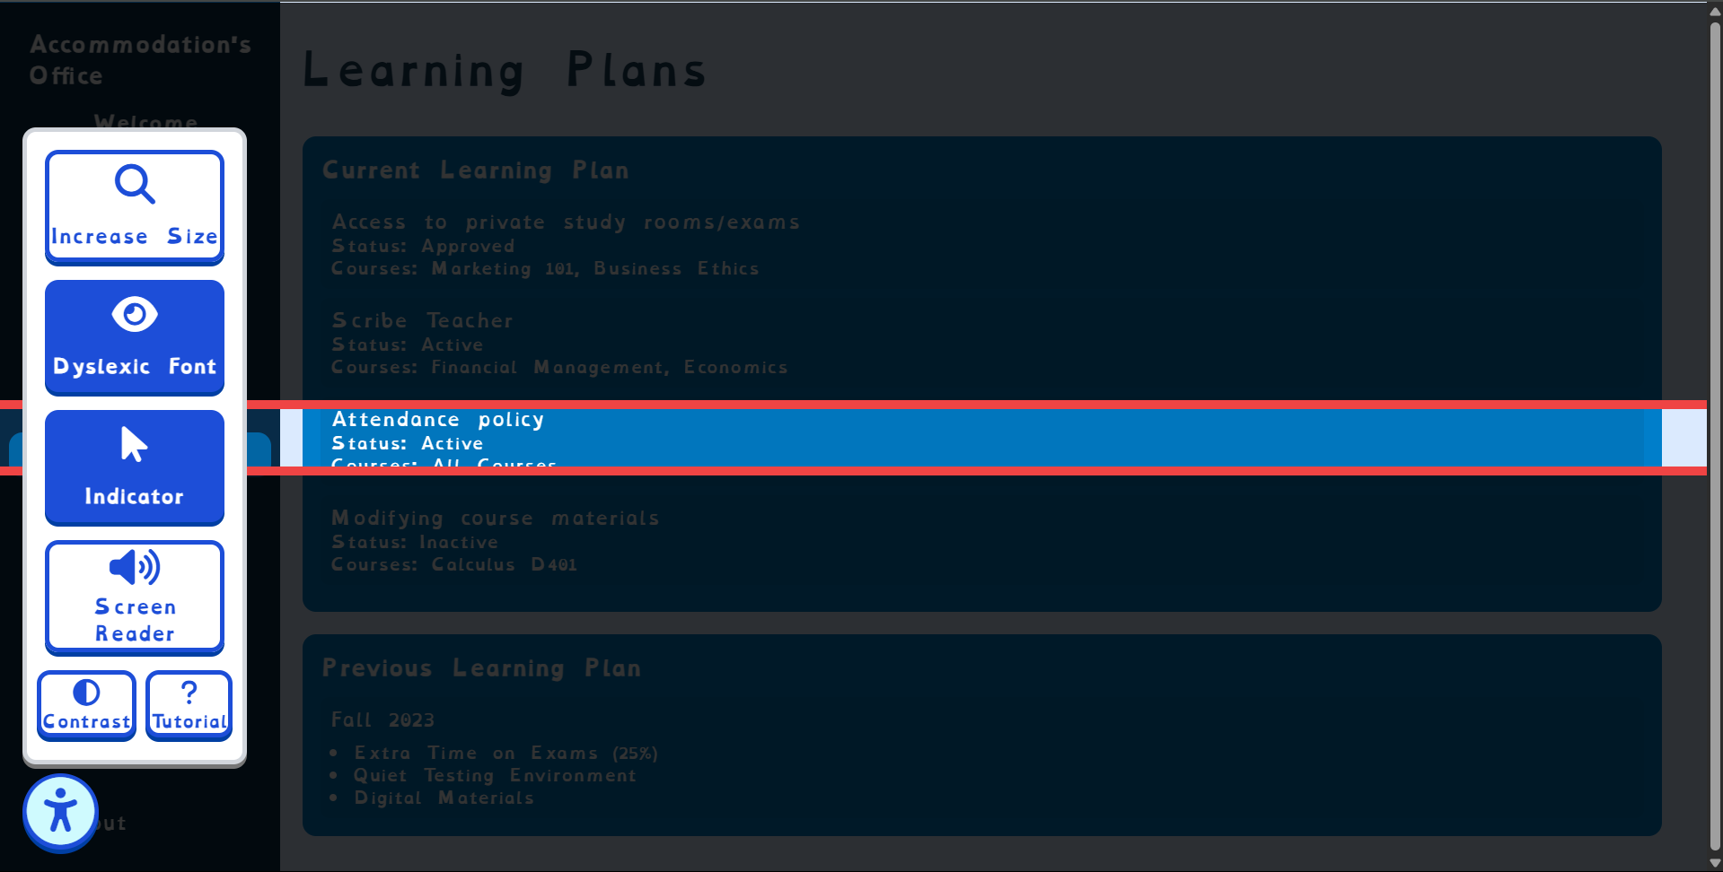

**Dashboard for Staff**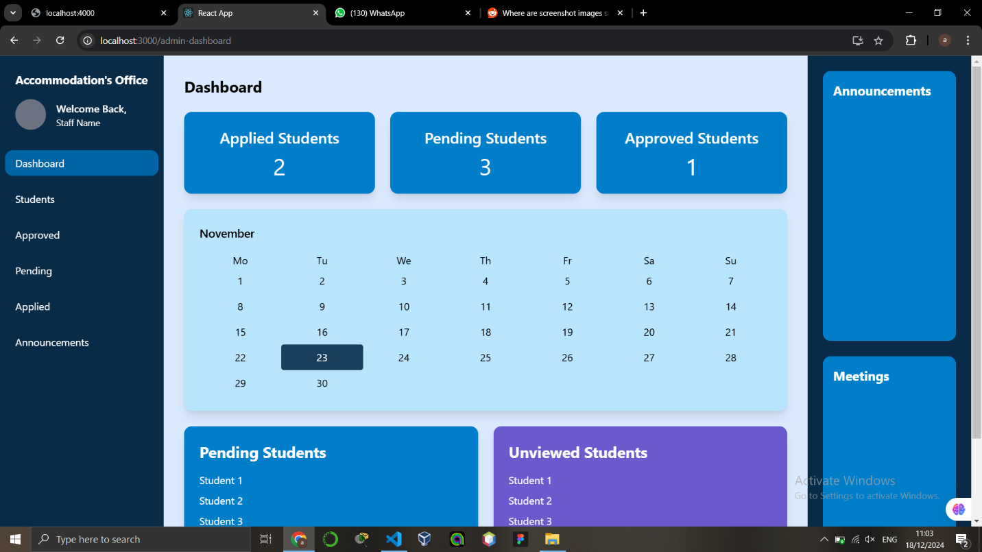

**Students List**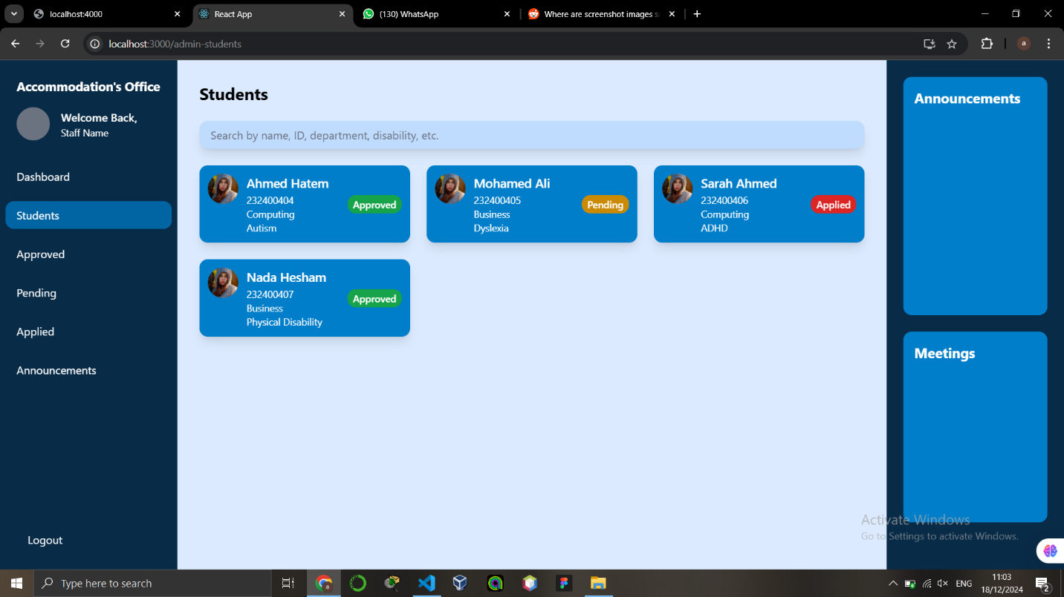

**Student Search**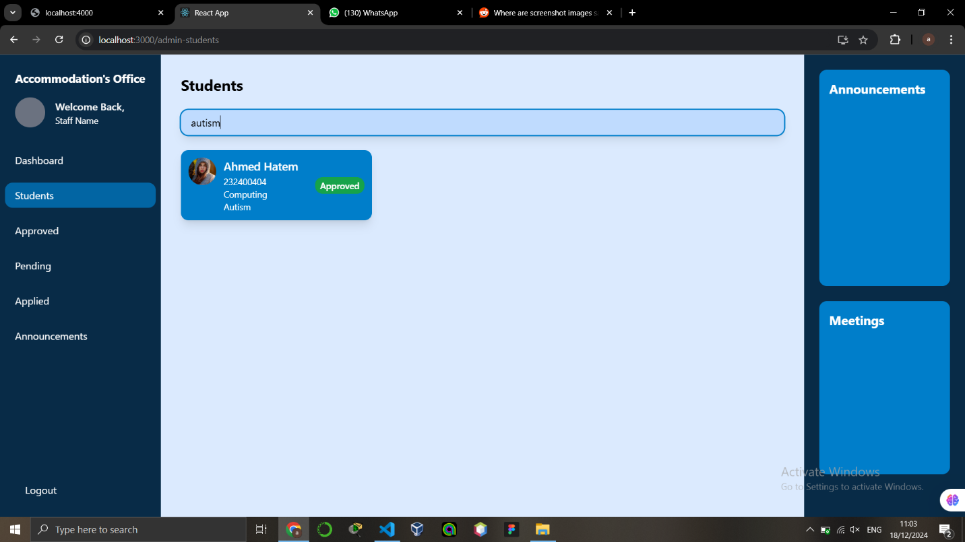

**Approved Students**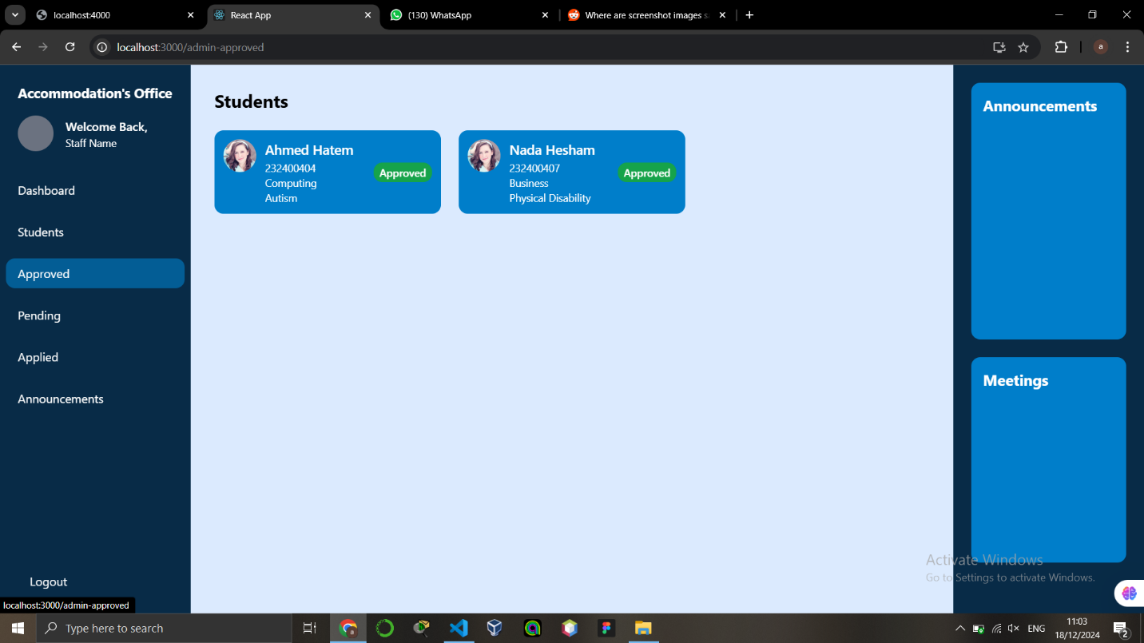

**Pending Students**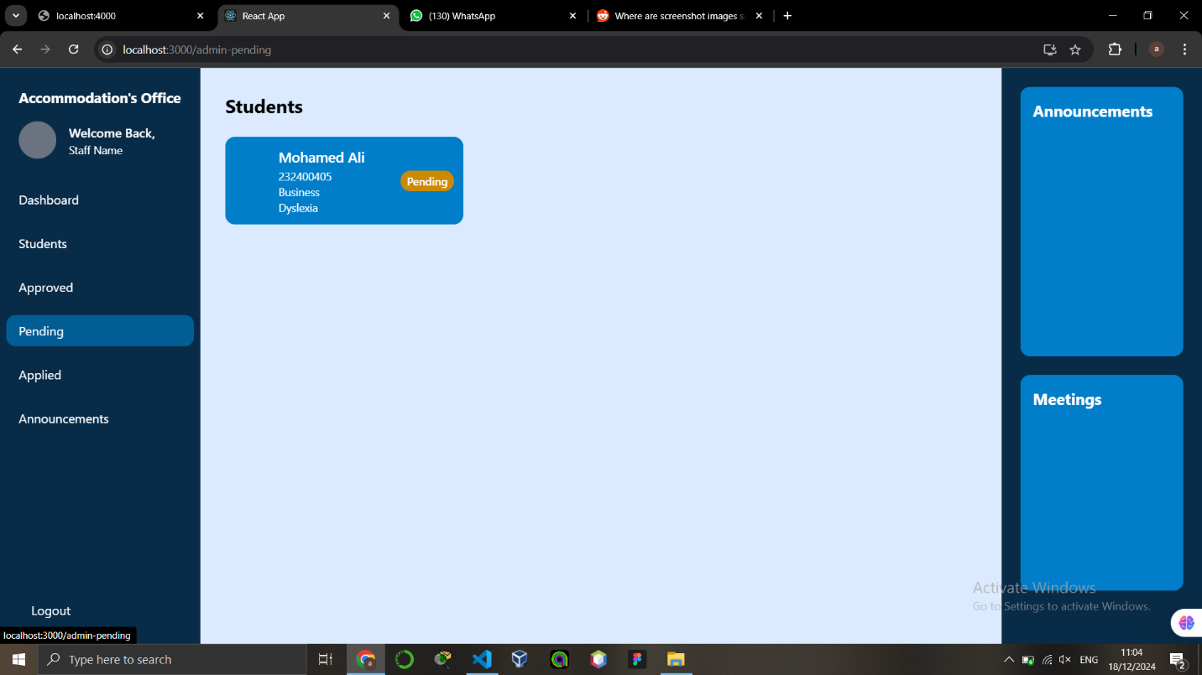

**Applied Students**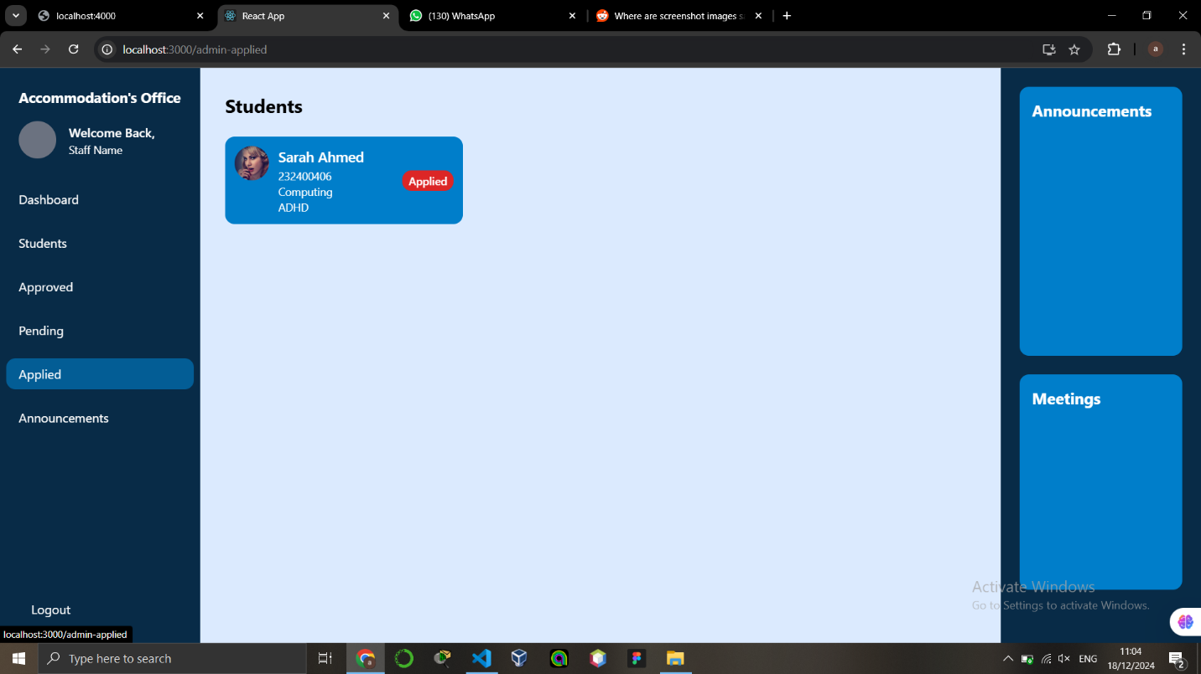

**Announcements**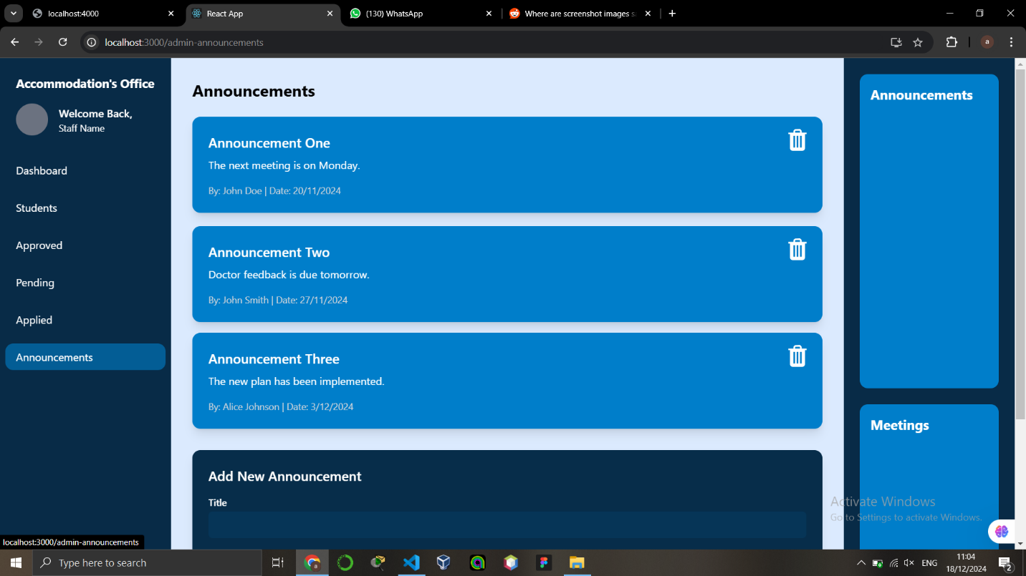

**Create Announcement**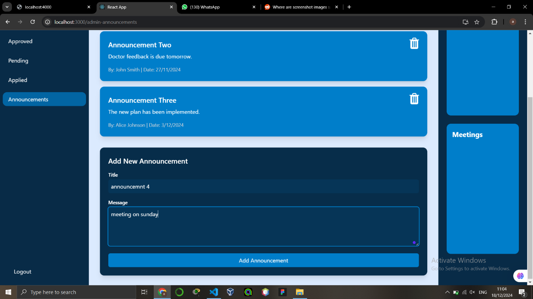

**Student Learning Plan Academic Suport Form**

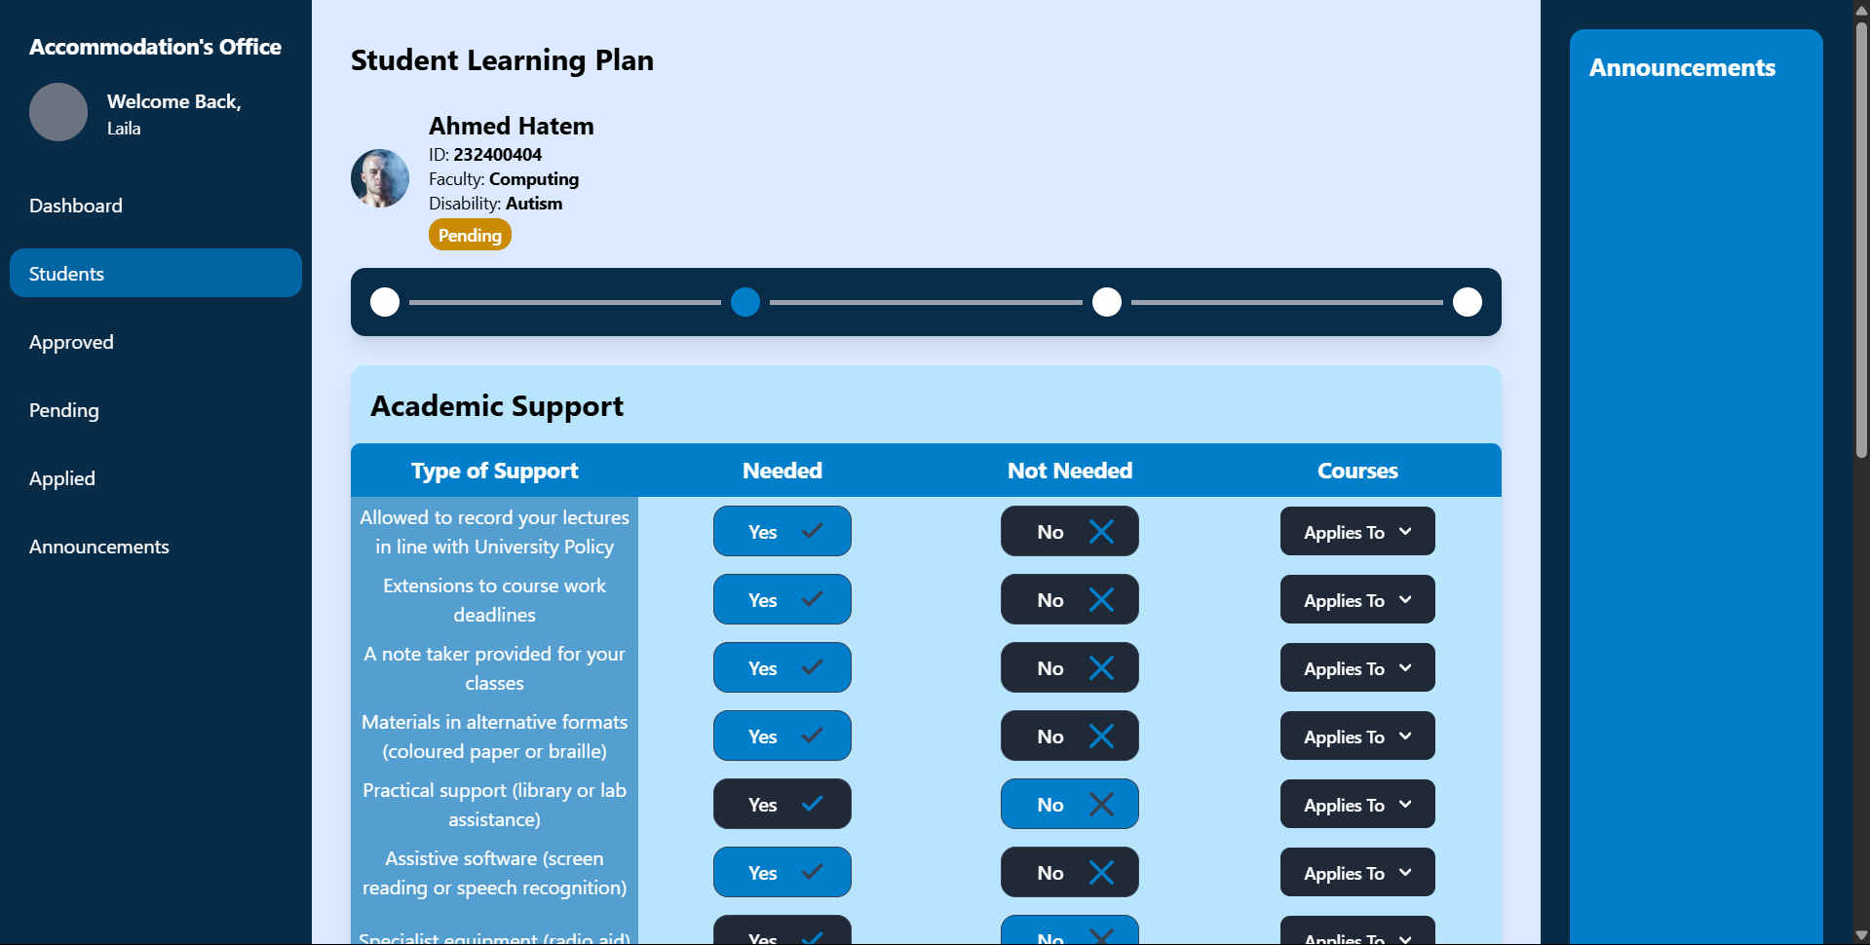

**Student Learning Plan Exam Support Form**

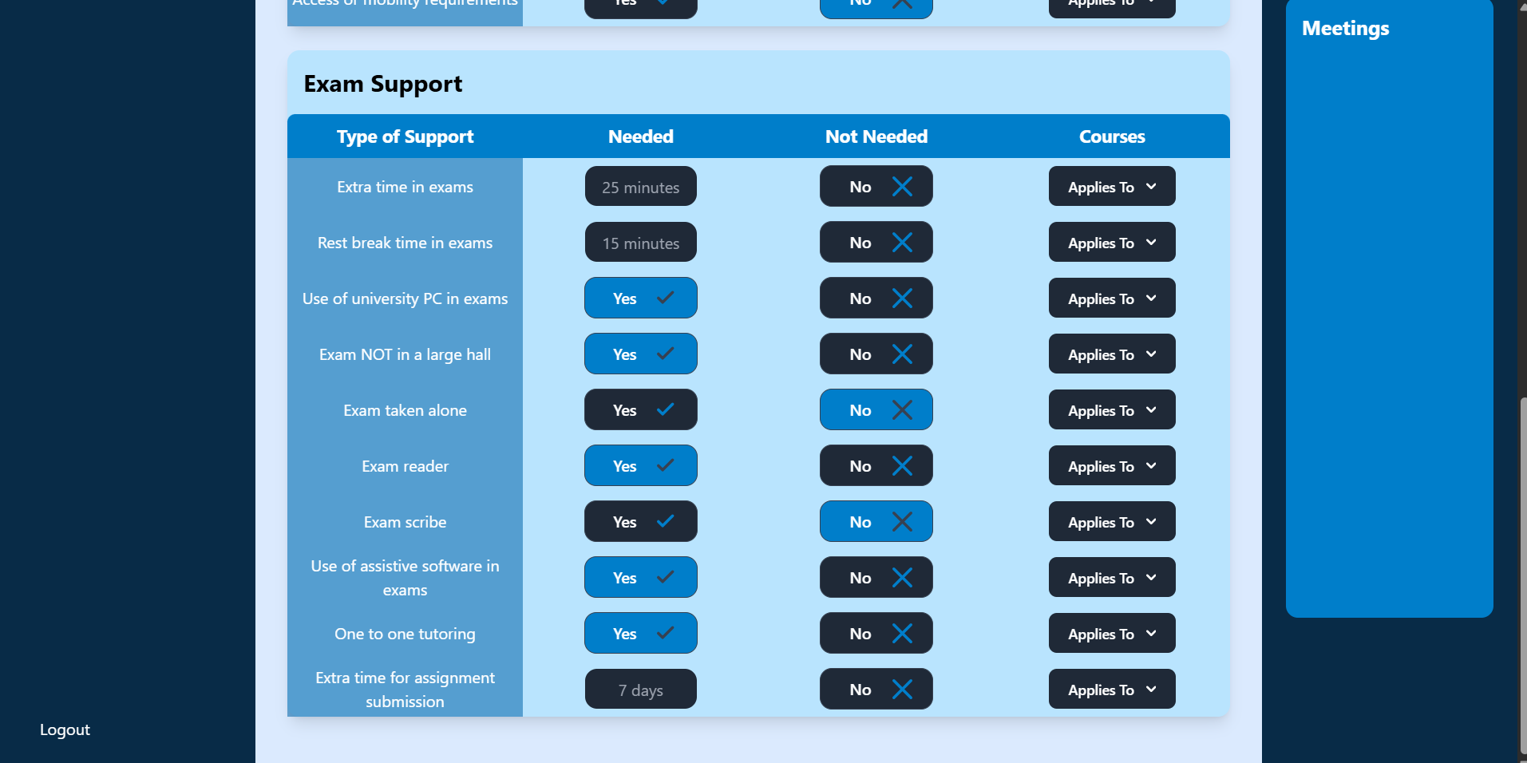

**Applied Student Section in Admin**

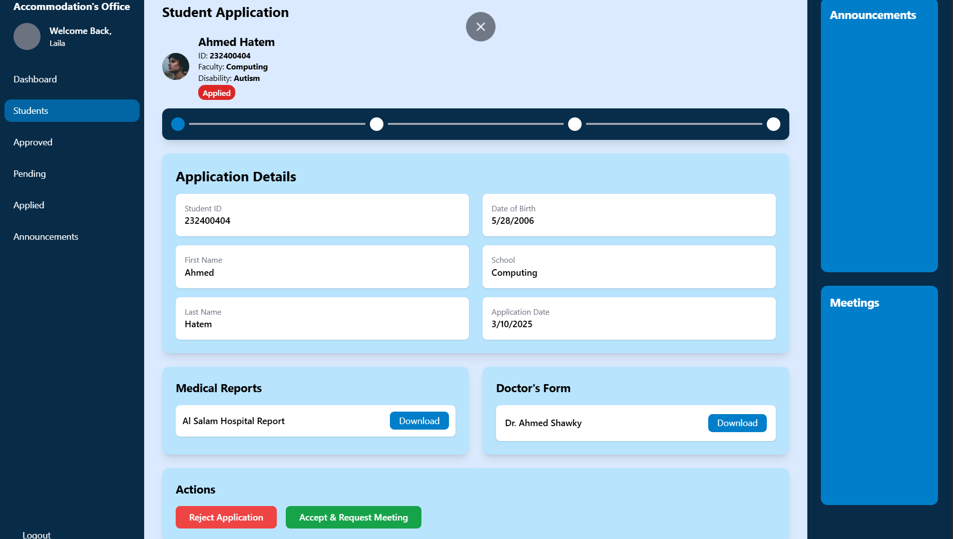

**Database Preview**

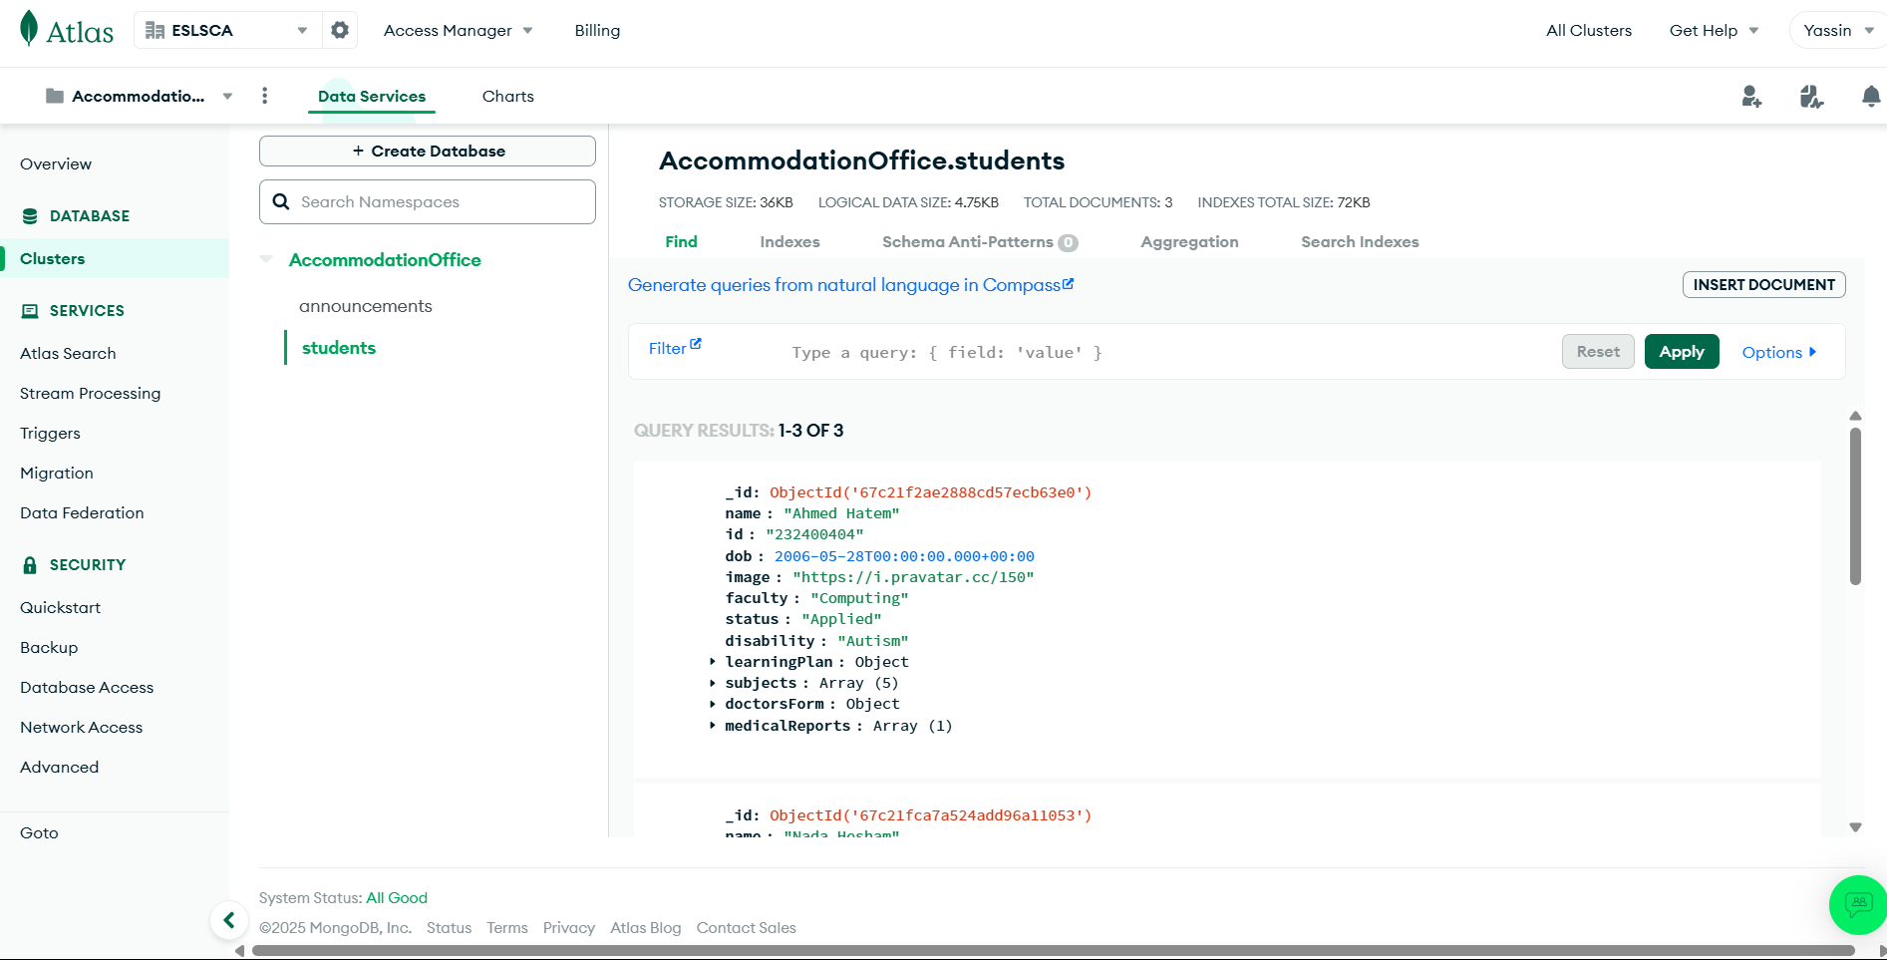

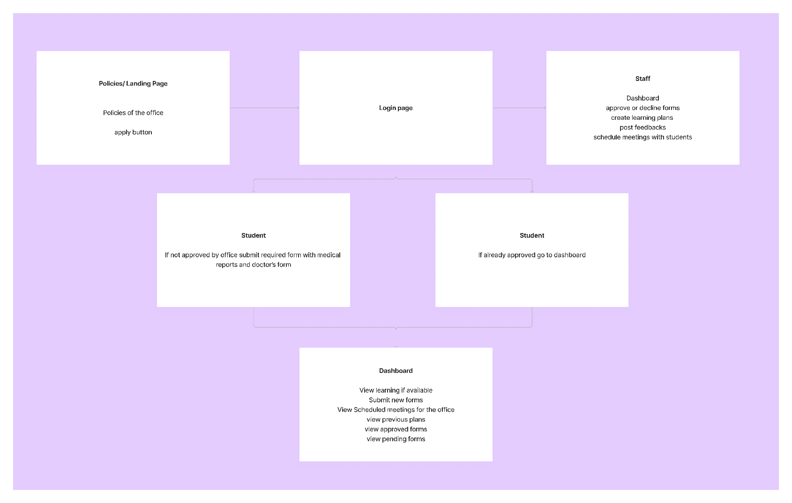**Website FlowChart**